Assignment – 2

Real-World Devices Using SMPS and UPS:
- Devices Using SMPS
No. | Device | Why it uses SMPS
1 | Desktop Computer | SMPS converts AC power into the different DC voltages required by the motherboard, CPU, storage, and other components.
2 | Laptop Charger/Adapter | It converts AC electricity from the wall socket into regulated DC power required to charge and operate the laptop.
3 | LED Monitor/TV | SMPS provides stable and efficient DC power to the electronic circuits and display components.

- Devices Using UPS
No. | Device | Why it is uses
1 | Desktop Computer | A UPS provides temporary backup power during power cuts and protects the computer from sudden voltage changes.
2 | Wi-Fi Router | A UPS keeps the router running during short power failures so that the internet connection can remain available.

2. Labeled Diagram of a Typical Desktop PC SMPS: 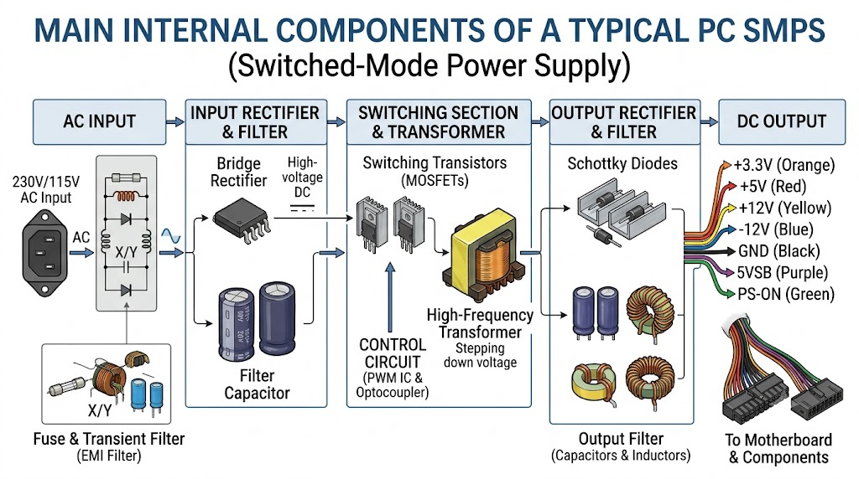
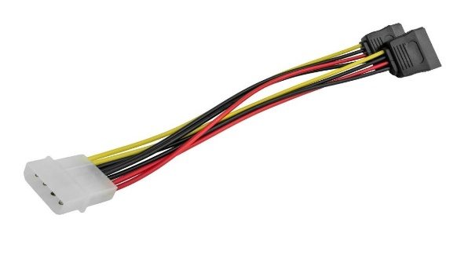
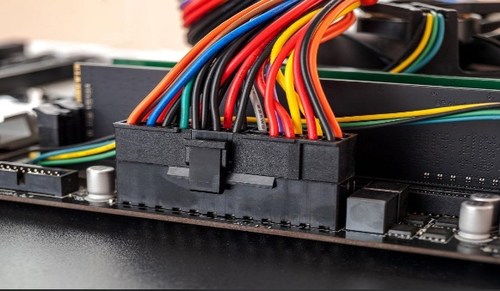
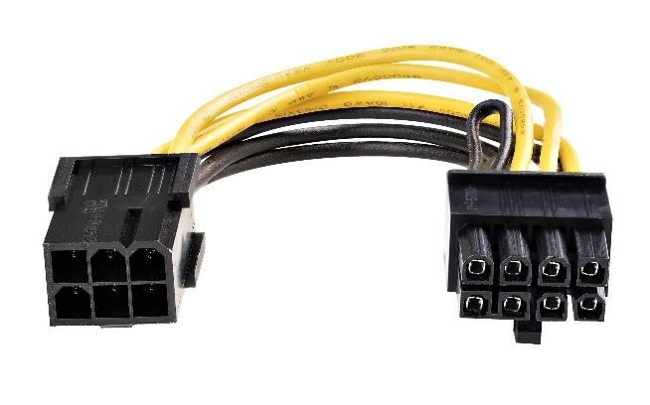
3. Power Connectors:
Molex Connector (4-Pin Peripheral)
Devices Powered: Older HDDs, optical drives, fans, and accessories
Safety Tip: Hold the connector body while removing it instead of pulling the wires.
SATA Power Connector
Devices Powered: SATA HDDs, SSDs, and optical drives
Safety Tip: Align the connector correctly; never force it into the port.
ATX 24-Pin Motherboard Connector
Devices Powered: Motherboard
Safety Tip: Switch off and unplug the SMPS before connecting or disconnecting it.
PCIe 6/8-Pin Power Connector
Devices Powered: Dedicated graphics cards (GPUs)
Safety Tip: Make sure the connector is fully inserted and use the correct PCIe cable from the PSU.
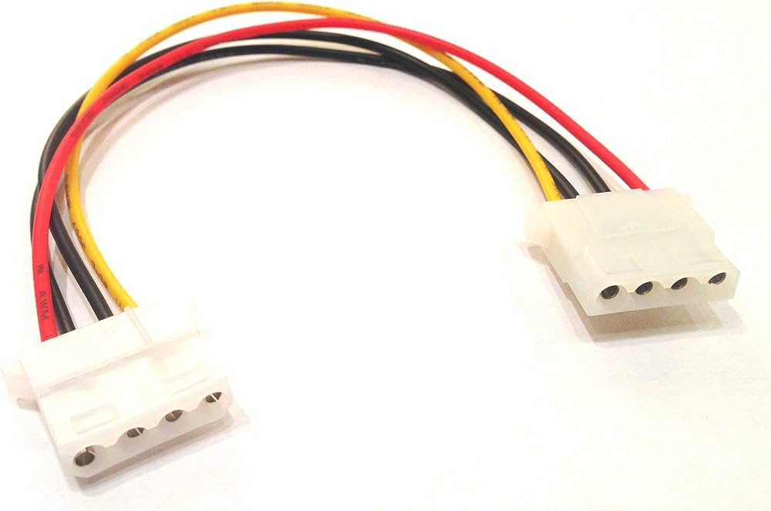

4. Connecting SMPS to a New Gaming PC:
Step-by-Step Procedure:
- Step 1: Turn off the power
Switch off the PSU and unplug the PC from the wall socket.
- Step 2: Install the SMPS
Place the SMPS inside the PC cabinet and secure it with the screws.
- Step 3: Connect the motherboard
Connect the 24-pin ATX motherboard power cable from the SMPS to the motherboard’s 24-pin ATX socket.
- Step 4: Connect CPU power
Connect the 4/8-pin CPU/EPS cable to the CPU power connector near the processor socket.
- Step 5: Connect the graphics card
For a dedicated GPU, connect the required PCIe 6-pin/8-pin cable (or the GPU’s specified power connector) from the SMPS to the graphics card.
- Step 6: Connect storage devices
Connect a SATA power cable from the SMPS to SATA HDDs, SATA SSDs, or optical drives.
- Step 7: Connect other components
Connect power cables to compatible case fans or other accessories if required.
- Step 8: Check all connections
Make sure every connector is properly seated and no cable is loose or interfering with the fans.
- Step 9: Connect AC power
Connect the SMPS power cord to the wall socket and switch on the PSU.
- Step 10: Test the PC
Turn on the computer and check whether the motherboard, GPU, storage devices, and fans are working correctly.

